Specification for Sliding roof covers - Amaala project at Intake pump house
Sliding roof covers, referred to as retractable or sliding roof systems, are structures that can open or close to cover outdoor or indoor spaces, providing flexibility for light, ventilation, and weather protection.
Note: Provided snap below & details shared are indicative. However, vendor can share their proposal for our review
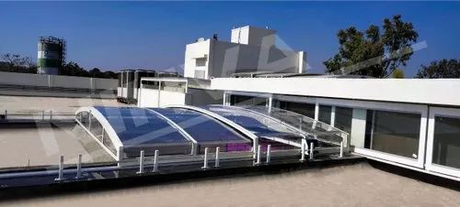
Technical Specification: Polycarbonate Opaque Sliding Roof Cover with Aluminum Frame
General Description
- Roof Cover Type: Sliding roof cover consisting of two panels
- Purpose: To cover an RCC slab roof cutout, providing protection from sunlight, dust, and rain while allowing mechanical ventilation
- Location: Saudi Arabia, designed for local environmental conditions
Materials
- Covering:
  - Type: Polycarbonate opaque sheets
  - Thickness: 6mm to 10mm (to be finalized based on structural analysis)
  - Properties: High impact resistance, lightweight, UV-stabilized, and opaque to block sunlight
- Frame:
  - Type: Aluminum alloy (6063-T6 or equivalent)
  - Properties: Corrosion-resistant, strong, and suitable for high-temperature environments
Dimensions
- Roof Cutout Size: Refer shared drawing for actual dimensions
- Panel Configuration: shall be proposed by vendor
Panel Operation
- Mechanism: Manually operated
Structural Support
- Frame Structure: Aluminum frame with reinforced joints to withstand wind loads and thermal expansion
- Mounting: Securely anchored to the RCC slab using stainless steel bolts and weatherproof seals to prevent water ingress
Sealing and Weatherproofing
- Seals: EPDM rubber or silicone seals between panels and frame to prevent dust and water entry
- Drainage: Integrated gutter system with downspouts to manage rainwater runoff
Environmental Considerations
- Temperature Resistance: Materials rated for temperatures ranging from -20°C to 50°C, accommodating Saudi Arabia’s climate
- UV Resistance: UV-stabilized polycarbonate sheets to prevent degradation from prolonged sun exposure
- Dust Resistance: Smooth surfaces and sealed edges to minimize dust accumulation and facilitate cleaning
Safety Features
- Locking Mechanism: Automatic locking system when panels are closed to ensure security
- Emergency Stop: Manual override and emergency stop button for the motorized system
Maintenance
- Access: Removable panels or access hatches for periodic cleaning and maintenance
- Durability: Corrosion-resistant materials selected for long-term performance with minimal upkeep
Compliance
- Standards: Designed to comply with the Saudi Building Code (SBC) and relevant ASTM standards
- Certifications: Manufacturer to provide material and system certifications confirming quality and suitability
Loading
- 150kg/m2 shall be considered over the panels as Live load

